**Experiment No. 8**

PART A

(PART A: TO BE REFFERED BY STUDENTS)

**A.1 Aim:**

Back End Development Phase 2

**A.2 Prerequisite:**

Core java programming and basic knowledge of database

**A.3 Outcome:**

**After successful completion of this experiment students will be able to**

1. Create Database of an application using SQLite or MySQL database

**A.4. Procedure:**

**Tasks:**

a) Create database of your application or backend functionality

b) Paste the code of database

c) Save the document as **EXP8_ your Roll no.**

PART B

(PART B: TO BE COMPLETED BY STUDENTS)

**(Students must submit the soft copy as per following segments within two hours of the practical. The soft copy must be uploaded on the Blackboard or emailed to the concerned lab in charge faculties at the end of the practical in case the there is no Black board access available)**

|  |  |
| --- | --- |
| Roll No. B046 | Name: Pranav Joshi |
| Program: B.tech Computer | Division: B |
| Semester: B3 | Batch : B |
| Date of Experiment: 1-4-15 | Date of Submission: 9-4-15 |
| Grade : |  |

B.1 Task to be done:

**1)** Paste Source code of .xml and .java files in this section along with output.

package com.example.database;

public class Product {

private int _id;

private String _productname;

private int _quantity;

public Product() {

}

public Product(int id, String productname, int quantity) {

this._id = id;

this._productname = productname;

this._quantity = quantity;

}

public Product(String productname, int quantity) {

this._productname = productname;

this._quantity = quantity;

}

public void setID(int id) {

this._id = id;

}

public int getID() {

return this._id;

}

public void setProductName(String productname) {

this._productname = productname;

}

public String getProductName() {

return this._productname;

}

public void setQuantity(int quantity) {

this._quantity = quantity;

}

public int getQuantity() {

return this._quantity;

}

}

package com.example.database;

import android.database.sqlite.SQLiteDatabase;

import android.database.sqlite.SQLiteOpenHelper;

public class MyDBHandler extends SQLiteOpenHelper {

@Override

public void onCreate(SQLiteDatabase arg0) {

// TODO Auto-generated method stub

}

@Override

public void onUpgrade(SQLiteDatabase arg0, int arg1, int arg2) {

// TODO Auto-generated method stub

}

}

<Button

android:id="@+id/button1"

android:layout_width="wrap_content"

android:layout_height="wrap_content"

android:text="@string/add_string"

android:onClick="newProduct" />

<Button

android:id="@+id/button2"

android:layout_width="wrap_content"

android:layout_height="wrap_content"

android:text="@string/find_text"

android:onClick="lookupProduct" />

<Button

android:id="@+id/button3"

android:layout_width="wrap_content"

android:layout_height="wrap_content"

android:text="@string/delete_text"

android:onClick="removeProduct" />

import android.app.Activity;

import android.app.ActionBar;

import android.app.Fragment;

import android.os.Bundle;

import android.view.LayoutInflater;

import android.view.Menu;

import android.view.MenuItem;

import android.view.View;

import android.view.ViewGroup;

import android.os.Build;

import android.widget.EditText;

import android.widget.TextView;

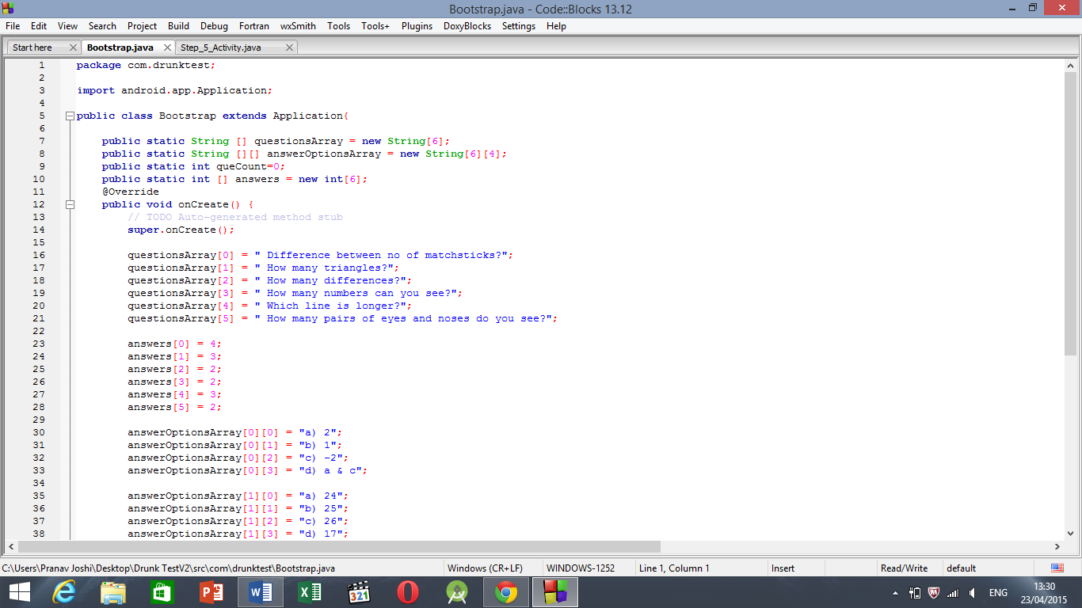

B.3 Conclusion:

Hence we recorded our progress in theoretical application of database generation.